**Nunua Pamoja Application Architecture and Design**

1. Software Architecture
2. **Application Requirements**
3. Technologies
4. Programming/Scripting Languages

* HTML
* CSS
* JAVASCRIPT
* PHP
* MYSQL

1. Frameworks

* Laravel (backend)
* Vuejs(Frontend)

1. Libraries

* JQuery
* Bootstrap

1. Tech Stacks

* LAMP
* WAMP

1. **Domain and Hosting**
2. **APIs**

* Pusher API
* SMS API
* Mailing API
* Drop shipping API

1. **Web Application Architecture**

1. **Nunua Pamoja Application Architecture**

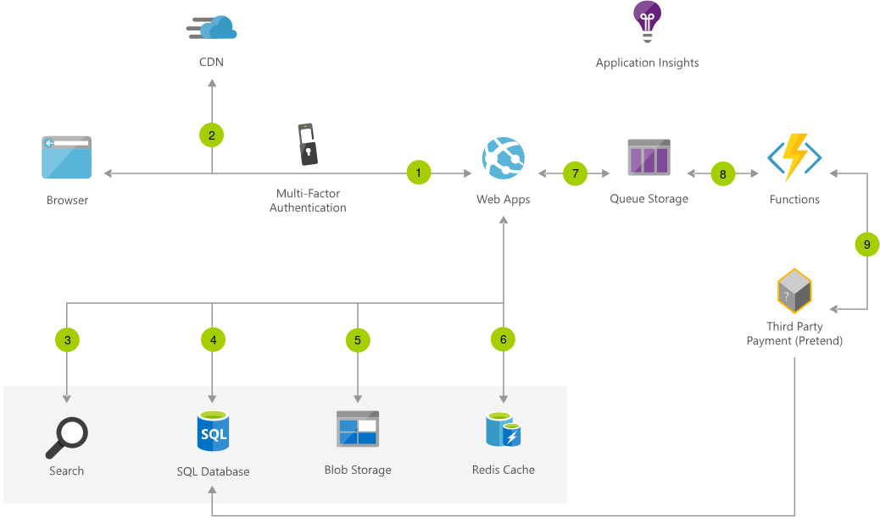

***Data flow***

1. Authentication

* User accesses the web app in browser and is authenticated.

1. Possible Authentication Types
2. session-based auth
3. OAuth
4. Suitable Authentication Methods
5. Password-based authentication
6. Multi-factor authentication
7. Biometric authentication

***Suitable Methods***

1. Facial recognition
2. Fingerprint scanners
3. Eye scanners
4. Frontend/ User Interface

* Browser pulls static resources such as images, products .etc.
* User will Access the app based on their assigned Authorization Roles.

**Important Authorization Roles**

1. Super Admin
2. Admin
3. Developers/Engineers/Technical Team
4. Users (Individuals, retailers, distributors)

***MAIN USER INTERFACE FEATURES***

1. Dashboards
2. Store
3. Products
4. Cart

**Features**

* Payment Methods

1. Basket
2. User Profile
3. Application Management and Settings Dashboard
4. Plugins
5. Product Search engine (Powered by Intelligent AI)
6. Trending Baskets Suggestion (Powered by Intelligent AI)
7. Augmented and Virtual Reality
8. Customer Online Support

* User searches for products and queries SQL database.
* User adds product to cart(Their own personal cart)

1. Backend/APIs
2. Application Packages/ Modules
3. AI powered Product search engine.
4. Authentication Module (e.g. Laravel Jetstream, Laravel Breeze)
5. The Intelligent AI Package/Module (Main Package in Nunua Pamoja APP)
6. Product Management Module/Package
7. Location
8. Product
9. Price
10. Outlets/pick up stations
11. Suppliers/Factories
12. Application Insights/Settings Package: Detect, triage, and diagnose issues in web apps and services
13. Load Balancer Packages (e.g. Laravel Forge)
14. Communication and Notification Packages
15. Application APIS
16. Payment Gateways(Integrated, MPESA, Stripe, PayPal etc.) or We already our own payment API
17. Delivery APIs/Drop shipping APIs
18. Customer Online Support (Autodesk)
19. Mailing Services (Mail Chimp)
20. SMS services (Bulk SMS)
21. Other Features
22. Queuing Systems
23. Pusher API or (Acquire Dedicated IP and we use web sockets)

* Web site pulls product catalog from database.
* Web app pulls product images from Blob Storage.
* Page output is cached in Cache for Redis for better performance.
* User submits order and order is placed in the queue.
* Payment API Functions processes order payment.
* Intelligent AI places cart products into respective Baskets
* Once the basket is ready Intelligent AI alerts factories/Suppliers
* Factories/Suppliers releases Products
* Intelligent AI processes products delivery (i.e. each customer gets all their cart products delivered to the nearest pick-up stations/Outlets )

***Components***

1. Web Apps: An App Service Web App runs in a single region, accessible to web and mobile browsers
2. Payment APP
3. Ecommerce APP(Nunua Pamoja APP)
4. Application SQL Database: Managed, intelligent SQL in the cloud
5. Application Packages/Modules and APIS
6. **Nunua Pamoja Application Software Design**